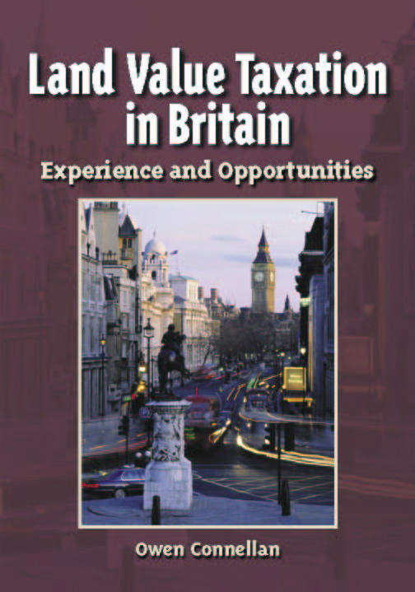

ISBN 1- 55844 – 157 - 3
Published by the Lincoln Institute of Land Policy, Cambridge MA USA April 2004, 214pp.

Normal price $20 + $6 p&p from US

As a contributing author, I am able to order this topical book direct from Lincoln at 25% discount, to my personal contacts only.
SPECIAL PRICE:
£13.50 inc. p&p
To qualify for this offer, orders must be received
by 30 June 2004 & accompanied by cheque to “Modern Maps” using form below.

Order form (send to: Modern Maps, c/o 62 Craven Road, Newbury, Berks RG14 5NJ):
Please send me __ copies of “LVT in Britain” @£13.50
TOTAL SUM ENCLOSED £ .
(payment by cheque only, payable to “Modern Maps”)

Signature

Books will be despatched within 28 days, subject to stocks being available. Your payment will not be processed until your goods are despatched.

Address for delivery of book(s):-

Name: ____________________ Phone: ______________

Address: ________________________________________
Postcode: _______________ (offer applies to UK only, email tonyvickers@cix.co.uk for overseas orders)

Abstract
Attempts at introducing land value taxation (LVT) in the United Kingdom demonstrate a long and varied history. Land Value Taxation in Britain considers this history and how LVT may be particularly relevant at the present time. Owen Connellan, with contributing authors Nathaniel Lichfield, Frances Plimmer and Tony Vickers, explores past debate over different forms of LVT, the tax’s role in generating government revenue, and its practical operation, moral background and ethical rationale. The book concludes with a discussion of future prospects for LVT in Britain and elsewhere.
But why study land value taxation in Britain, especially when that country has yet to evolve a system of LVT that is generally accepted or workable? Britain’s experience with property taxation and expertise on property valuation make it an ideal case study. Only by examining the success and failure of past legislative and administrative attempts to employ LVT for the benefit of the community can policy makers draft more effective LVT proposals, not just in the U.K. and but also in other countries.
Land Value Taxation in Britain seeks to open up a challenge for future discussion on this form of taxation. Students and professionals focused on taxation matters will find it of interest, as will the general reader who may not have a technical background in economics and taxation.

From the Foreword by C Lowell Harriss:
“Land Value Taxation in Britain provides us with a summary of British experience in land taxation, and of the thinking that has guided attitudes and actions on this point. It offers valuable assistance in making important tax policy choices. . . . Yet, Land Value Taxation in Britain is more than bare history; it can help in making history.”

